Rupert Rowley
Development Chef – MSK Ingredients
Goats Cheese Panna Cotta in a spiced Tomato jelly and pesto Powder

Recipes
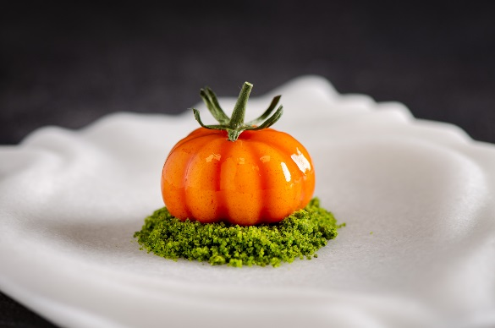
Pesto Powder
40g Pesto
60g Ultrasec powder
10g parmesan (fresh microplaned)
10g pine nuts (toasted, chopped)
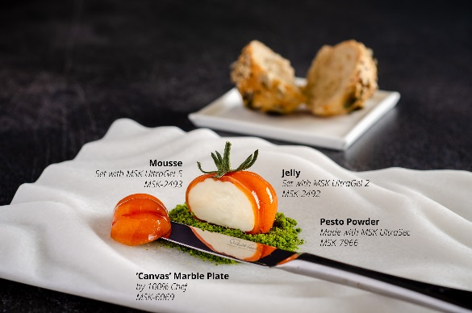
Goats Cheese Mousse
300g goats cheese log
200g milk
200g cream
7g Ultragel 5
- Put the goats cheese and the cream into the Thermomix and set to 70c
- Boil the milk and add the Ultragel 5 (use a little maltodextrin / ultralin to help to disperse)
- Bring the mix back to the boil 1 – 2 minutes
- Pour into the cream and cheese mix
- Adjust the seasoning and pour into moulds

Tomato jelly
300 g Big Tom (tomato juice)
10g Tomato powder
6g Ultragel 2
- Put the tomato juice in a pan and bring up to 80 c
- Mix the tomato powder and the Ultragel 2
- Whisk this mix into the juice and bring up to the boil
- Boil for 2 minutes to activate the gelling agent.

Graeme Cheevers
Chef Patron – UNALOME

Roasted Orkney Scallop, Cauliflower, Finger Lime and Smoked Mussel Sauce

Serves 4

Scallops
4X large hand dived Orkney Scallops
20g Pomace Olive Oil

Sauce
300g Double Cream
50g White Wine
100g Vermouth
250g Fish Stock
2 Shallots (Sliced)
1 Clove Garlic (Sliced)
4 Smoked Mussels
4 Finger Limes

Cauliflower Puree
300g Cauliflower (Sliced)
200g Milk
200g Butter
100g Onion

Herb Oil
200g Green Herbs
400g Vegetable Oil

Herb Cream
10g White Wine Vinegar
1g Xanthan Gum
10g Mustard
40g Egg Yolk
150g Herb Oil
5g Lemon Juice
5g Garlic (blanched)
4g Salt
20g Fish Sauce

Garnish
4 Salty Fingers
4 Sea Fennel
4 Roasted Cauliflower Pieces

Method:
Start by making the herb oil, in a thermomix place the herbs and oil and blend on full speed for 7 minutes at 70oc. Once blended pass through a fine chinois into a container over ice and allow to cool.
Next make the herb cream, place the egg yolks, mustard, lemon juice, garlic, white wine vinegar, salt and xanthan gum into a clean mixing bowl and whisk until pale, gradually add the herb oil until fully emulsified, then finish with the fish sauce. Place to one side and keep cold. Keep the remaining herb oil to one side.

To make the smoked mussel sauce take a saucepan and add the butter place the pan on a medium heat and add the shallots and garlic, season lightly with salt and cook until translucent, next add the vermouth and white wine and reduce to a glaze, add the fish stock and reduce by half, now add the cream and bring to the boil.
Leave the sauce to rest for 30 minutes before passing through a fine chinois.
Once passed add the smoked mussels and blend until smooth. Finish by adding the finger lime and remaining herb oil.

For the cauliflower puree take a medium sized pan and add 100g butter and the onion, cook until translucent and season lightly, next add the cauliflower and season further, cook quickly until the cauliflower starts to break down. Next add the milk and bring to the boil. Cook for 5 minutes or until cooked. Transfer the mixture to a blender and blend well, add the remaining butter and check the seasoning before passing through a fine chinois.

Now to finish the dish sear the scallops in a hot pan on one side with the oil until cooked.
Plate the dish with the cauliflower puree and herb cream, add the roasted cauliflower, salty fingers and sea fennel and finish with the sauce, pour over the remaining herb oil.

Brown Crab, Dashi Custard and Truffle Jelly

2x Large cock crabs
20g Salty Fingers
20g Bronze Fennel

Dashi Custard

QUANTITY | INGREDIENTS | PREPARATION
400g | Dashi
50g | Cream
4 | Egg Yolks
4 | Eggs
2g | Ginger
0.5g | Lime Zest
3.5g | Soy Sauce
2 | Kaffir Lime Leafs

PROCEDURE:

- Mix all ingredients
- Steam 83oc for 20mins
Dashi Jelly

QUANTITY | INGREDIENTS | PREPARATION
400g | Dashi
2.5g | Agar
4 Sheets | Bronze Gelatine
25g | 50/50 Stock Syrup
8g | Chopped Truffle
40g | White Soy Sauce

PROCEDURE:

- Bring the Dashi, Soy sauce to the boil with the agar
- Soak the gelatine until bloomed.
- Add the gelatine to the boiled dashi.
- Cool on ice and add the chopped truffle.
- Once set, whisk the jelly into small pieces.

Dan Ashmore
Group Executive Chef - Dean Banks Restaurants

Scallop, Umeboshi Plum, Fermented Raspberry, strawberry vinegar and elderflower dressing

1 x raw xl Orkney scallop
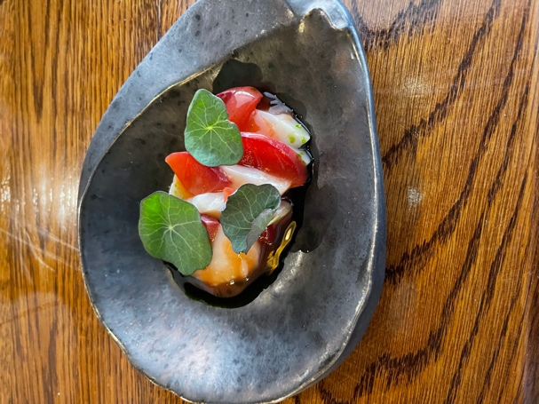
15ml dressing
5ml nastursium oil
¼ umeboshi plum

Scallop Prep
Open Scallops, remove roe and skirt, reserve for other dishes. Wash meat and pat ry. Reserve in the fridge.

Umeboshi Plum
10 plums
2% BLACKTHORN salt
50ml gin

Wash plums lightly. Weigh the plums, weigh 2% of the weight of the plums as salt.
Place in a large bowl, rinse with the gin and sprinkle with the salt. Vacuum pack fully and leave somewhere warm for 7 to 10 days. The bag will expand, keep rotating it so the plums are constantly washed by the liquor.
Once fermented, place in the dehydrator for 2 days.
Keep in the fridge for service.

Dressing
100g Fermented raspberry
150ml strawberry vinegar
200ml elderflower syrup
10g gochujang
5g BLACKTHORN salt

Blend all together, pass, check seasoning, place in squeezy bottle for service

Fermented raspeberry
1kg raspeberry
20g BLACKTHORN salt

Mix together, vac pack, leave somewhere warm for 10 days.

Strawberry vinegar
500g strawberries
700ml rice wine vinegar

Boil vinegar, pour over strawberries, leave for 1 month until needed

Elderflower syrup
1L water
250g elderflowers
2 lemon zest and juice
500g sugar

Boil, infuse and pass.

Nasturtium Oil
500g nasturtium leaves
500g neutral oil (grape seed etc)

Place in thermomix, blend on speed 10 for 1 minute, speed 6, 80-degree heat for 8 minutes.
Chill over ice water, strain through muslin/J-Cloth, place in a piping bag, hang to allow the water to collect in the tip of the piping bag, snip the bag, drain the water and keep the oil

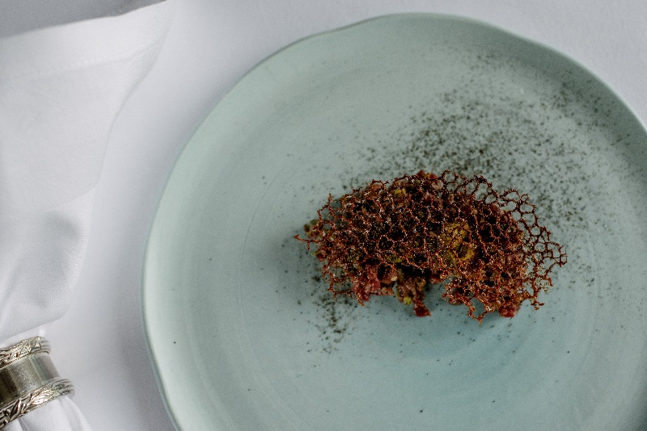
Venison Tartare, confit egg

50g Venison Meat
MARA Kombu Juniper Salt
MARA Kombu juniper Oil
Cep Crisp
10g Brunoised Shallot
10g Brunoised Gherkin
6g Finely Chopped Capers
10ml fermented cep juice
5g Pickled Rock Samphire (not sea fennel)
Confit Egg Puree
Mushroom Powder

Venison Prep – CRITICAL CONTROL POINT

This must be prepped as fast as possible, in the butcher’s area.

Seam bone the venison haunches so they are single fibre muscle pieces. Remove any sinew, marinade in rapeseed oil, thyme and bay and freeze. Take upstairs in the pompadour kitchen and sear in a very hot pan to kill any bacteria on the outside of the meat. Chill Immediately.

Get a yellow, ready to eat board, and trim the seared outside off the meat. Dice to a 0.5cm size and store in a labelled cling filmed container.

Only sear and dice what you need for the day. Use the pax to portion calculator

For service, take a clean bowl for each portion, weight the amount of venison needed, add the gherkins, shallots and capers, season with cep juice, kombu salt and juniper kombu oil. CHECK WITH SENIOR CHEF.
Plate and serve immediately

All utensils to be washed in the dishwasher, all utensils to be used once then cleaned.

Cep Tuiles
125g flour
200g veg oil
180g frozen ceps
12g BLACKTHORN salt
1300g water

Blend all together, rest for an hour, pan fry in veg oil on a medium heat. CHECK WITH SENIOR CHEF

Confit Egg Puree
200ml pasteurised yolk
250 smoked oil
50g sherry vinegar
10g BLACKTHORN salt
Cook the eggs at 64 degrees with a little of the smoked oil and the salt, for 1.5 hours.

Blend with the smoked oil, sherry vinegar and season if needed.
CHECK WITH SENIOR CHEF

Juniper Kombu Salt
40g juniper
25g kombu flakes
20g Mushroom powder
50g BLACKTHORN salt

200g BLACKTHORN salt.

Blitz the first set of ingredients at a high speed, turn down to 1, add the 200g Maldon and mix for 10 seconds

Juniper Dulse Oil
100g Juniper
50g MARA DULSE SEAWEED
1L Rapeseed oil

Toast the juniper and kombu, infuse with the warm oil.

Fermented Cep Juice
1kg frozen cep
20g BLACKTHRN salt

Method
Defrost the ceps, mix with salt and vacuum pack. Leave somewhere warm until the bag starts to expand. Leave for 1 week, open the back and check the juice, if it needs longer, re-vac and place in the warm area for a few more days.

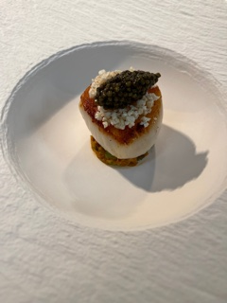
Scallop, Dashi, Kimchi

1 x 60g scallop, brushed with scallop
butter, seasoned with smoked scallop roe
15g spring onion kimchi
40ml MARA KOMBU dashi
5ml kafir lime oil
1g airbag – seasoned with chipotle powder
5g caviar (supplement)
2g deep fried kafir lime julienne (normal)

Scallop Prep
Open scallops gently, remove and wash the skirt – reserve for scallop butter.
Remove the roe and rinse lightly
Brine for 20 minutes

Scallop Brine
1000ml water
50g BLACKTHORN salt
10g lemongrass
5g kafir lime

Method
Boil salt, water and aromats. Blast chill. Reserve until needed.
Brine washed scallops for 20 minutes then discard the brine

Scallop skirt butter
500g butter
250g scallop skirt
1 lemon
8g BLACKTHORN salt

Method
Lightly oil and season the skirts then roast for 20 minutes at 180. While the skirts are roasting, dice the butter and add to a warm pan. Take to buerre noisette and stop with the juice from the lemon, add the salt then the roasted skirts. Infuse for 60 minutes then pass.
Check with senior chef

Smoked Scallop Roe
200g scallop roe
1L water
10g BLACKTHORN salt

Method
Bring the water and the salt to the boil, blanch the scallop roe for 30 seconds
De-hydrate at 70 overnight
Place the roes in a gastro container, wrap tightly with clingfilm and smoke twice with the smoking gun.
Check with senior chef

Kimchi
100g spring onion sliced
30g kimchi dressing

Method
Mix spring onion with dressing, store in a container with a j-cloth below and above

Kimchi Dressing
6 bunches spring onion
1 tub gochujang paste
6 thumbs ginger (peeled and chopped)
6 thumbs galangal (peeled and chopped)
70ml fish sauce
BLACKTHORN Salt

Method
Blitz all together in the thermomix until it forms a fine paste
Check with senior chef

Dashi
150g Shitake mushrooms
100g MARA Kombu seaweed
100g Bonito flakes
6L Water
BLACKTHORN Salt

Method
Soak the kombu in cold water overnight. Place the soaked kombu and mushrooms in a pan with the water. Warm gently, never boiling, infuse for 30 minutes, pass and add the bonito flakes. Infuse for a further 30 minutes and pass.
Check with senior chef

Kafir Lime Oil
100g Kafir lime leaf
100ml grapeseed oil

Method
Place oil and leaves in the thermos at speed 10 for 1 minute, then blitz at speed 6, heat 70 for 10 minutes. Chill In a bowl over ice, then pass through muslin, hang in a piping bag to allow the oil and water to split, drain the water and keep the oil.
Check with senior chef

Milk chocolate Espuma, Cherries and Lemon Verbena
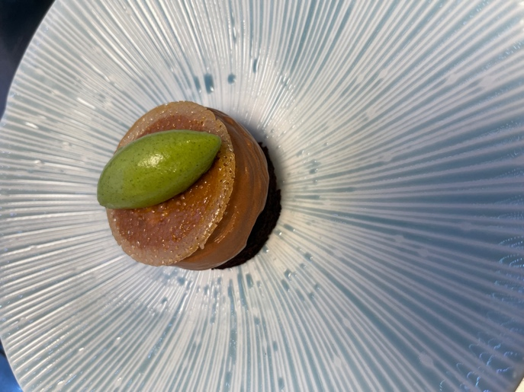
Chocolate Espuma (60 portions)

Ingredients:
- 2 L Barista soymilk A
- 120g sugar B
- 12g salt B
- 12g Pectin X58 B
- 520g Brazilian chocolate 66.8% C
- 5g Xanthan gum D
Method
Add ingredients B together whilst bring soy milk to a boil. When milk boils add B and whisk and bring back to a boil. Pour over the chocolate, blitz with a bamix till smooth. Cling film on contact and let chill till set. Once cold then add xanthan blitz and pass, bag up in 500g bags.

When needed for service blitz mix again, (it should return to liquid saucy consistency). Load into espuma gun 500ml with 1 cream charge. Shake well before use.

Chocolate Opaline Tuile
Ingredients:
- 200g Fondant A
- 200g isomalt A
- 90g chocolate B
- 2g Salt B
Method:
Bring A to 155 degrees then whisk in B and set on silcpat mat. Once cooled blitz into a powder.
Using a cutter as a stencil generously dust the powder to the shape required. Repeat several times onto tray and bake at 180 degrees for 5 mins.
Fermented Cherries
Take 1 kg of cherries and lacto ferment for 1 week. ( 1kg fruit + 2% salt 20g. Vacuum and leave at room temp )
Ingredients:
- 1kg fermented cherries A
- 150g Water A
- 110g sugar B
- 10g yellow pectin B
- 15g Raspberry vinegar C
Method:
Bring cherries and water to a boil. Then add the sugar and pectin mix and simmer till cooked. Once cooked add vinegar and cool.
Stone sugar
Ingredients:
- 1kg apricot (will provide 25g of stone seeds)
- 275g sugar
Method: destone apricots. Wash and dehydrate for 2 hours. crack open stone and reserve seeds. Blend seeds with sugar in thermos. Store till needed.
Mascarpone mousse insert (90 portions)
Ingredients:
- 500g mascarpone A
- 300g double cream A
- 200g yolk B
- 100g sugar stone mix B
- 100g warm amaretto C
- 4 leaves gelatine (rehydrated) C
- 300 egg white D
- 125g Sugar D

Method:
Stage 1 whip A together and set aside. Next make the sabayon using B set aside. whilst that’s happening mix together C, once that is done decant into a bowl. Then start making merengue D. whilst that’s going on, add C to B then fold in A finally fold in D. Each stage is made in kitchen aid. Make sure to clean bowl between usages.

Vegan Insert (90 portions)
Ingredients:
- 1kg vegan philly
- 1kg coconut milk
- 100g sugar stone mix
- 100g caster sugar
- 100 amaretto
- 50g ultratex
Method:
Mix all ingredients together and blitz till smooth in thermomix in 2 stages.
Chocolate Sponge (makes 3 gastros 84 portions)
Ingredients:
- 720g gluten free strong bread flour A
- 800g sugar A
- 20g salt A
- 40g bicarb A
- 100g cocoa red brute A
- 20g cep powder A
- 60g white wine vinegar B
- 360g rapeseed oil B
- 800g cold water B
- 200g espresso B
Method:
In big mixer add A dry ingredients and mix. Then separately add B together and slowly add the liquid to the dry mix making sure to create a smooth batter.
Pour into a gastro lined with parchment paper roughly 1 kg of mix in each tray. Cook at 160 for 15min on fan 1. Cool, freeze and cut whilst frozen.

Lemon Verbena Ice cream

Ingredients:
- 1 liter Milk
- 350 gram Cream, Double
- 280 gram Sugar
- 70 gram Glucose
- 100 gram Milk powder
- 6 gram MSK Ice Cream Stabiliser
- 180 gram Egg Yolk ; about 9
- 400g of blanched lemon Verbena
- INSTRUCTIONS cook all in Thermomix!
- 1. Heat milk, cream to 65C in Thermomix
- 2. Combine sugar, glucose, nonfat milk solids and stabilizer and whisk well (powder only) to prevent lumps.
- 3. Add sugar mixture and egg yolks to milk and blend with an immersion blender.
- 4. Continue to emulsify while using a digital thermometer to check the heat. Bring the mixture to 85?C for three seconds, then immediately chill in ice bath.
- 5. When mixture is cool, strain through a chinois while blending with an immersion blender to break up gumminess.
- 6. Let base mature for 4 hours in the fridge then blend with 440g of blanch and chopped lemon verbena in stages. blend once again and freeze in one-pint deli (pacojet) cups.
- 7. The base will be ready to go in the Pacojet the next day ( will need to be pacoed twice before use.
- Run ice cream 1 hours before service - this gives it time to re-freeze to the optimal temperature for serving.

Culinary Legend Willie Pike

Please see a very special link to all Chef Willies recipes – simply stunning – when you access this link you will be so Inspired and exited about food and especially – blown sugar fruits.

Culinary legend Willie Pike's Recipes

By seeing the great recipes – your creative thoughts will expand

Also Chef Willie wishes to Inspire lectures from all over Great Britain on Continual Professional Development Culinary adventures with Him – Legend

To learn more please contact Willie on williepike@btinternet.com or call him on 07753 578660

Have fun and be inspired

Ross Sneddon

Executive Pastry Chef -The Balmoral Hotel – Edinburgh

Quince, white chocolate, pistachios and olive oil
Components
3 x roasted pieces of quince
3 x scoops tiny of quince sorbet
1 x 16cm x 2.5cm Strip of white chocolate flexi ganache
20g quince gel
1 x small meringue shards with vanilla powder
8g Olive oil maltos
3 x Dice Pistachio cake 2 cm x 2cm
Pistachio paint
lemon thyme
Maldon salt

Roasted quince Pieces
6 x Quince
Method
● Peel quince and cut to size
● Place the quince in vac pac bag
● Add the compressing syrup and brandy
● Vac pac and store overnight
● roast the following day in hot oven

White chocolate flexi ganache
900g white chocolate Felchlin
1500g double cream
270g staboline
150g glucose
6g salt
10g sugar
7g agar
24g gelatine bloomed
Seeds from 2 vanilla pods
Method
● Combine the cream, vanilla seeds staboline and glucose
● Mix the agar , salt and sugar
● Whisk the agar mix into the cream and bring to the boil
● Remove from the heat add the gelatine
● Strain over the chocolate and emulsify
● Pour into a silver tray lined with a guitar sheet and set overnight

quince gel
1000g quince puree
300g pear puree
150g sugar
20g agar
6g gelatine bloomed
Method
● Mix the sugar, agar and X58
● Whisk into the purees
● Bring to the boil , cook for 2 minutes
● Add in the gelatine and strain
● Cover the surface with cling film and set over night
● Thermo until really smooth
● Store in piping bags

Pistachio cake
200g Butter
50g Pistachio Paste
200g Caster sugar
50g Trimoline
250g Fresh Eggs lightly warmed
200g Ground pistachios
100g Ground almonds
50g Soft flour
2g Xanthan gum
Method
● Cream butter, pistachio paste , sugar and trimoline
● Add in eggs
● Sieve the flour and xanthan gum together
● Fold in nuts and flour
● Bake in a frame , 4kg per frame at 180c
Olive oil maltos
800g extra virgin olive oil
500g maltos
200g icing sugar
2g salt
Method
● Mix the maltos and the sugar
● Rub the dry powder into the maltos to make a fine crumb
Pistachio paint
100g Pistachio paste
25g Grapeseed oil

Method
● Blend the two together and store until needed

Supporting The Royal British Legion – a very special recipe
Nan’s Marmalade Recipe The Royal British Legion - Website

History
The first marmalade was made in Dundee in 1791 by the Keiller family – I was brought up by my Nan who sadly passed away in April 2020 at the ripe old age of 106 ½ – and this is a modern version of her recipe. Living in Broughty Ferry in the late 60’s was a great time, fish from the sea and more importantly, at the time we were surrounded by fields of strawberries and logon berries. This is where I used to spend hours making jams and marmalade’s with my Nan. Dad’s first job was also a draftsman with Keiller’s.

Seville Orange, Honey and Whisky Marmalade
Ingredients
1.5 Kilo of Seville Oranges
500g Clear Honey
500g Granulated Sugar
4 nips of 10-year-old Laphroaig Whisky
1.2 litres of Water
Method
- Cut the top and bottoms off the oranges and make sure all oranges are of an equal height – then cut them into 8 segments and cut out all the flesh.
- Place all the flesh and chopped tops and bottoms of the oranges in a deep pan with the water – bring to the boil and simmer for 1.5 hours.
- When the flesh has broken down pass the mixture through 2 layers of muslin
- Cut the orange skin length ways into thin slices – place in the liquid and cook until they are soft – approximately 1 hour – then pass the liquid through a sieve.
- Reduce the passed liquid to 1.2 litres
- Mix the honey and granulated with the liquid and bring to the boil and cook for 10 minutes.
- Add the orange peel and cook further until setting point is reached. A good idea is the have a small plate in the freezer to help test for the setting point. Continuously skim whilst it is cooking.
- When setting point is reached remove from the heat and gently stir in the whisky.
- Pour the marmalade into preserving jars and cover.

Nan’s Scottish Oatcake Recipe Pre - First World War
History
This recipe has been in my family for over a century and dates back way before the First World War – estimated mid 1850’s
There are some recipes you can up date and some that are so good and simple it would be a crime to try and change them and this is one – just a simple addition of sea salt and milled white pepper.

Oatcake Recipe

1lb Scottish Oatmeal
8oz Plain Flour (sieved)
4oz Unsalted Butter
Sea Salt
Milled white Pepper
A touch of hot Water

Method
- Chop the butter and allow to soften
- Mix together the Oatmeal and flour and rub through the butter by hand
- Lightly season with the salt and pepper
- Add the hot water to form a dough (it will be warm to touch)
- Roll out the mixture to desired thickness and cut into disks
- Bake on a non-stick tray at 190c for 15 minutes (depending on thickness)
- Remove from the oven and place on a cooling rack and when cool enjoy with the marmalade

