|  |  |  |  |  |  |
| --- | --- | --- | --- | --- | --- |
|  | Name | **CGOC** | **Placing for CGOC** | **FINAL PLACINGS**  **GOLD – SILVER- BRONZE** | **UK CURRY CHAMPION**  **National Curry Chef**  **of the Year** |
| **1** | **Ashwani Kumar**  *Mango Lounge* | **Shellfish – LH15** | BIC | **SILVER** |  |
| **2** | **Zyeshan Mohammed** | **Street – LH13** | Bronze | **BRONZE** |  |
| **3** | **Steve Heap** | **Street – LH13**  **Starter – LH12** | Bronze  Merit | **BRONZE** |  |
| **4** | **Md. Al Amin Ali**  *Millennium Balti* |  |  | **BRONZE** |  |
| **8** | **Saskar Shawnim** |  |  | **GOLD** |  |
| **9** | **Amit Bagyal**  *Yaatra* | **Street – LH13** | BIC | **GOLD** | **UK CURRY CHAMPION**  **NATIONAL CURRY CHEF OF THE YEAR 2024** |
| **10** | **Md. Najib Ali**  *Maya* |  |  | **MERIT** |  |
| **11** | **Shanker Pandey**  *Everest Inn* |  |  | **BRONZE** |  |
| **11b** | **Narayan Pokhrel** | **Street – LH13** | Silver | **-** |  |
| **12** | **Shah Lalon Amin**  *Delhi 6* | **Street – LH13** | - | **MERIT** |  |
| **15** | **Rohan Wadke**  *Cameron House Hotel, Scotland* | **Starter – LH12**  **Veg – LH14**  **Shellfish – LH15** | BIC  -  SILVER | **GOLD** |  |
| **16** | **Jiwan Lal**  *Babur* |  |  | **GOLD** |  |
| **17** | **Jit Sunar**  *Mount Gurkha Village* |  |  | **BRONZE** |  |
|  |  |  |  |  |  |

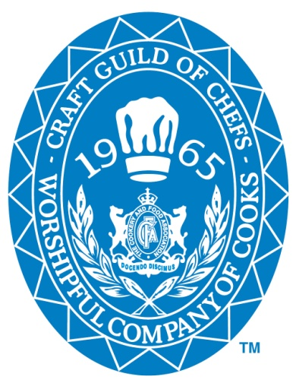**

Proudly Sponsored By