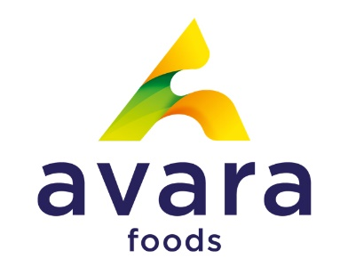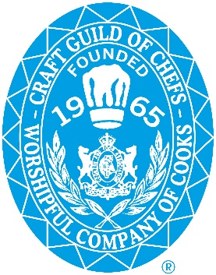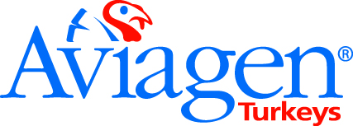

Entry Form
“British Turkey and British Duck Young Chef Challenge”

This competition as sponsored by Avara Foods and Aviagen Turkeys is a great chance to showcase your culinary skills.

Venue: Central Bedfordshire College

Date and Time: Tuesday 12th April 11am.
Who Can Enter: Student Chefs and Apprentice Chefs aged 23 or under as at 12th April 2022.

Details of the Competition: Competitors will have 60 minutes to produce 2 portions of a 2-course innovative menu featuring British Poultry, which will consist of a starter featuring British Turkey meat, and a main course featuring British Duck. The starter must contain British Turkey meat, either breast, leg or both, and the main course must contain British Duck meat, either breast, legs or both. The use of any other meat is prohibited from use in the dishes. All dishes must be suitable for all year-round and for banqueting style catering for servings of up to 300 covers. All recipes must be original. Competitors will also have 60 minutes preparation time prior to the start of the competition. The 2 winning dishes, starter and main, will be served at the 2022 British Poultry Awards on 22nd September 2022 at The Sheraton Park Lane Hotel. Please note the winning dishes may not be from the same entrant as dishes will be judged individually. The winners are invited to attend the awards to receive their trophy, and the opportunity of work experience at The Sheraton Park Lane preparing their dishes. They will also receive £100 of catering vouchers.
Name: …………………………………………………………………………………………………..

Contact tel no (Required): ……………………………………………………………………..

Email address: ……………………………………………………………………………………….

Date of birth: ………………………………………………………………………………………….

Address: ………………………………………………………………………………………………….

………………………………………………………………………………………………………………..

Postcode: ………………………………………………………………………………………………..

Name of college: ……………………………………………………………………………………..

Restaurant style Menu – using British Seasonal Produce:

Starter: ……………………………………………………………………………………………………

Main: ………………………………………………………………………………………………………

Entries to be sent directly to:

CMS Events
92 Marsh Road
Pinner
Middlesex
HA5 5NG

T: 07771 700626
E: cmsevents@btinternet.com

Deadline for entries 31st March 2022.

