YOUNG PASTRY CHEF OF THE YEAR 2024
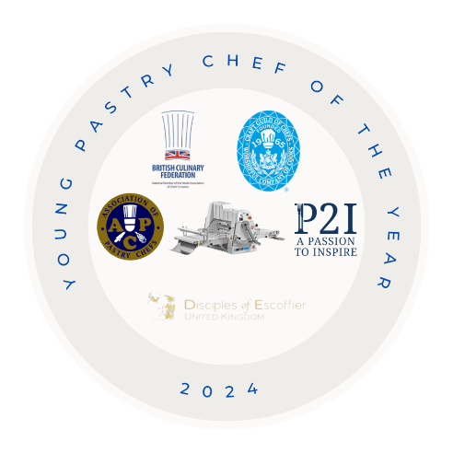

Format
The competition is open to any pastry chef aged 23 years and under on the 12th March 2024. The Candidate should be actively working in a hotel or restaurant kitchen, banqueting, college student or within any corporate/event catering environment.

Entry
You have to submit a fantastic plated dessert for 4 covers with Pictures - from this you will be judged on the contents of this entry to secure a place in the final - we would like to see a detailed sketch/drawing to accompany the plated dessert with detailed recipes, costing and rationale for concept...flavour/colour combinations, textures, sustainability, seasonality, historical influence etc. All the Challenges that you have been asked to create with recipes and costings and Inspire the Judges . This added information along with a photo of the finished dessert would add to the judging process and the candidates understanding of the task .
If you are successful and reach the final 18th June2024 At the University College Birmingham– you will be asked to create these additional challenges – please note there are hyperlinks in red to help your culinary adventure through the competition

1. Plated restaurant dessert (4 Portions) - 2 for Judges - 1 for Photographs - 1 for Guests and use Ponthier Puree in the creation of your dish Ponthier Puree
2. Produce All butter Puff Pastry – you may bring it but give 1 final book turn or 2 single turns using a Kemplex Dough Sheeter from NOWAH Nowah - Kemplex - Massimo Pica - Demonstration – from this you will be asked to make a 6 Pièce Mille Feuille filled with a flavoured crème mousseline, ( afternoon tea size )fresh fruit with a sugar caramelised top– and from the trimmings make 10 cheese straws both finish and flavourings are your decision .
3. Moulded Praline/ Bon Bon - 18 in total - 12 to be presented and 6 to the guests - using Great Chocolate from Ambassador Claire Clark – wonderful Chocolate from Amedei Toscana and click to learn and go on an adventure and a set Gel using Ponthier Puree

4. Create a dish – using Poached fruit – Tilda Jasmin Rice – Showing your Skills – Flavour – Texture – Infusion - Balance – Fragrance - using other ingredients to enhance the composition and presentation – served either Hot or Cold and serve as a tasting dish ( Whole or in Portions ) for 4 Judges. When the finalists are announced Harvir from Tilda will be in contact to help and support the finalists with Tilda Jasmin Rice Tilda Rice

For the costing exercise you will be using a 68% GP and 20% VAT.

Finalists will be required to prepare and present their dishes within a 4-hour timescale.
The Patisserie items may be presented in any order when ready to serve.

Finalists must supply all their own ingredients, equipment and presentation plates, menu and presentation documents and folder for the judges.

Lecturers/mentors/head chefs/ head pastry chefs - may be allowed to help set up and clear down but will not be present during the competition.

There will be 8 entrants invited to compete at the final.

All entries to Murray Chapman before 26th March, 2024 and the finalists will be notified on the 24th April, 2024 - any queries contact murray@firstcontactuk.com a panel of industry experts will select the 8 finalists.

Timings
All finalists are allowed to turn up a least 1.5 hours before start time to get prepared and have ingredients checked. The Judge’s briefing will be 15 minutes before the start - all finalists will start together.

Ingredients
There is to be no peeling of fruits, vegetables etc during the competition -please make sure that competitors have prepared all that is needed beforehand (Only what is allowed) for some recipes, competitors will not be able to produce everything in the allocated 4 hours. Please be advised, judges may ask you to fully explain the process you used for your preparation and to give a practical explanation.

- Work with Classic Fine Food to distribute samples of FROZEN Ponthier puree to the 8 finalists to use in trials
- Deliver puree to finalists for the final WC 10th June.

The only pre preparation which can be produced beforehand is:
Peeled fruit/vegetables but not cut
Ingredients weighed out/measured
Basic marinades
Filo pastry/not short or sweet pastry (must be made in the competition) - same with any fermented product
Dehydrated/dried fruits can be made before - preparation/process during the 3.5 hours
Sugar stocks/sugar blocks (for pulling)
Praline (praline must be made in the 4 hours)
Ice-cream and sorbets - All ice-creams and sorbets must be made during the competition (including bases)
Points will be deducted for excessive amounts of mis-en-place.

Judges
Chair of Judges, Claire Clark, Thomas Leatherbarrow, Matt Owens, Michelle Gilliot Stuart McLeod , Barry Johnson , Daniel Ayton

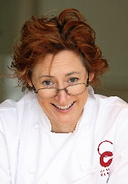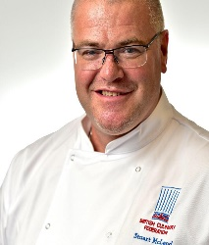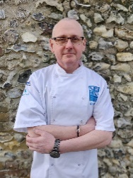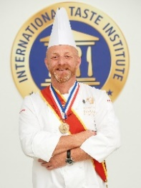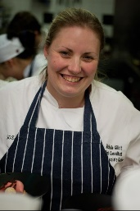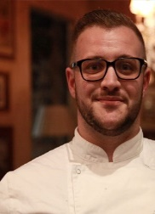

Judging Criteria
Flavour 30% Presentation 25% Innovation 15 % Hygiene 10% Working Method 20%
A Maximum of 10 points for each will be deducted for wastage and timings
Only judges and competitors may taste the products and final dishes

Please send Full names and Positions of all attendees / Support to Murray

Arrive from 9am -on the day and given time to set up -with refreshments available

Start time 11am for all competitors - the competition will last 4 hours - finish at 3 pm

Prep time for set up before the competition starts and finish your Puff Pastry on the Nowah / Kemplex Dough Sheeter

Presentation will be at 3.45 -with refreshments and special canapes to discuss

Feedback
Before the winner is announced - each competitor will be given individual feedback from the judges - with their presentation folders (lecturers/mentors/head pastry chefs/head chefs may attend - but not interact) - There will be NO feedback from the initial competition entries.

Prizes for Overall Winner and Finalists

The Winner will be going to on a great adventure – Upskill Sessions organised by NOWAH and for others involved we will try and organise stages with you and other great pastry Chefs supported by Kemplex Dough Sheeter from NOWAH
Special Culinary Adventure Learning Journey with NOWAH
Venice and Milan with NOWAH
Daniel Ayton from the Disciples of Escoffier a very special honour - orange Disciples Sash for the winner (a three year probation, for young chefs and service of promise)

Chefi Knife Case from Jazz for the overall Winner
Winning Trophy- plus Great support from Tilda Rice
TLC Gourmet – From Thomas Leatherbarrow - £100 worth of silkomat moulds for the winner and a special mould for each entrant

All finalists will receive a special Chef Jackets from Russums

Special treats from Paul at Ponthier (Apron, Maryse, Silpat, Cocktail shaker, small pastry knife, squeezy bottle) and bespoke décor three boxes of chocolate décor or one case (125) transfer sheets. The free personalised chocolate décor is via our sister company, PCB Creation and NEW - Ponthier will give 10kg free puree to the winners employer / College

And a very special book from Hodder Education for each finalist signed by all the judges Written by Mick Burke – The Professional Patisserie

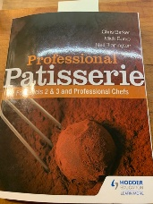

By entering this competition all entrants agree that The Association of Pastry Chefs and The Craft Guild of Chefs and The British Culinary Federation , Disciples of Escoffier reserves the right to use any material submitted, included but not limited to photographs, for any purpose connected with the competition.

Social Media Contacts – Young Pastry Chef – Facebook – Young Pastry Chef Instagram – Young Pastry Chef – Twitter

Note - " A Massive thank you to everybody that has supported / given advice and direction to the development of this Year's Competition - and to Inspire the next generation of Pastry Chefs " Murray

