Stay ahead of the game
with Gastronomixs.com
Do you find it challenging to quickly create new menus? Do you scarcely have any time to experiment with new preparations? Do you sometimes have the feeling you can’t keep up with the latest culinary trends? Then Gastronomixs is your answer!

Gastronomixs is an online idea generator, that enables over 26,000 (!) professional chefs to quickly create new dishes. Do you want to try out this modern platform, completely free of charge? Then we’ve got some good news for you! The Craft Guild of Chefs has a special limited time offer… which you can find below.

Building blocks for chefs
The idea generator works as follows: Gastronomixs provides recipes in the form of building blocks, also called components. These are not dishes, but preparations of one single ingredient such as raw asparagus juice foam, tomato-coated avocado, passion fruit granita or poached salmon. With these components, you can quickly create new dishes or adjust existing ones.

Discover the benefits
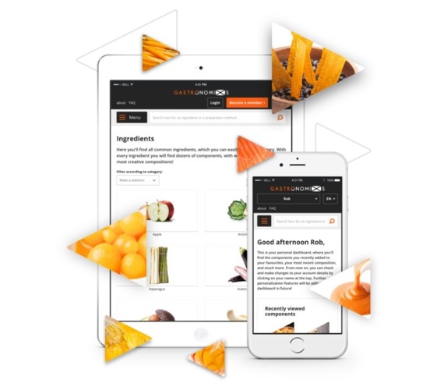
• New tried-and-tested recipes every week
All recipes have been tried and tested, which saves you a lot of time!
• Available within arm’s reach, anywhere, anytime
We're here whenever you need us, on any screen.
• All culinary inspiration in one place
Chefs and specialists from across the world share their knowledge with you.
• Made for and by professional chefs
We speak the same language and understand the challenges you face.

Special offer for you
Curious how inspiring Gastronomixs can be for you? We've got a special offer for all members of the Craft Guild of Chefs. Only in May & June, you can take out a free two-month account to give the platform a test-drive! Go to www.gastronomixs.com/en/couponcode, use the coupon code "CG419" and be inspired.

Coupon code: CG419

